React – HQL OUTPUTS

Name : G.S.R.Hemanth

Superset Id : 6124988

1. Cricket App

**Step – 1 :** Create a react app named cricketapp.

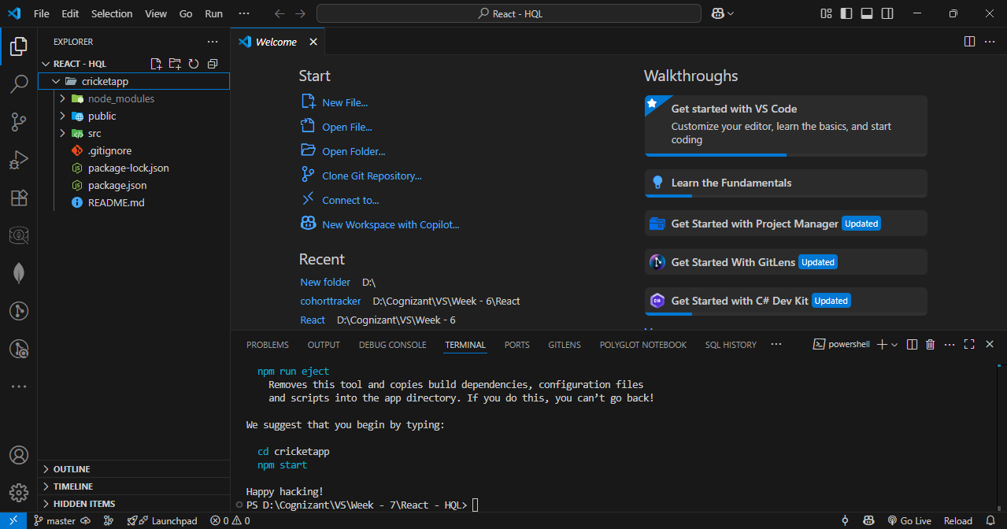

**Step – 2 :** Create a js file named ListofPlayers and enter details of players in it.

**Code :**

import React from 'react';

const players = [

{ name: 'Virat', score: 100 },

{ name: 'Rohit', score: 88 },

{ name: 'Rahul', score: 67 },

{ name: 'Jadeja', score: 71 },

{ name: 'Pant', score: 62 },

{ name: 'Ashwin', score: 56 },

{ name: 'Hardik', score: 74 },

{ name: 'Bumrah', score: 45 },

{ name: 'Gill', score: 85 },

{ name: 'Shreyas', score: 59 },

{ name: 'Kuldeep', score: 68 },

];

const players70 = players.filter((item) => item.score <= 70);

const ListofPlayers = () => {

return (

<div>

<h2>All Players</h2>

<ul>

{players.map((item, index) => (

<li key={index}>

Mr. {item.name} <span>({item.score})</span>

</li>

))}

</ul>

<h2>Players with Score ≤ 70</h2>

<ul>

{players70.map((item, index) => (

<li key={index}>{item.name} - {item.score}</li>

))}

</ul>

</div>

);

};

export default ListofPlayers;

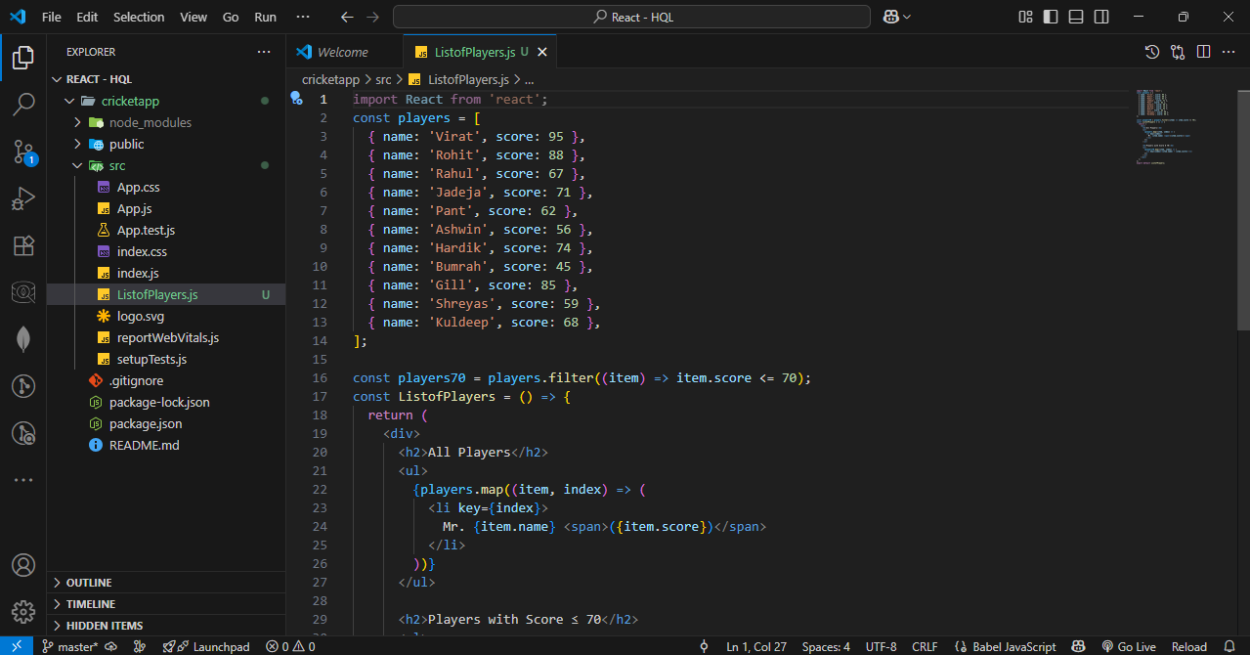

**Step – 3 :** Create two js files named oddplayer.js and evenplayer.js. Display them using the Destructuring features of ES6.

**OddPlayers.js**

**Code :**

import React from 'react';

export function OddPlayers({ players }) {

const oddPlayers = players.filter((_, index) => index % 2 === 0); // 0,2,4,...

return (

<div>

<h3>Odd Team Players (1st, 3rd...)</h3>

<ul>

{oddPlayers.map((player, index) => (

<li key={index}>{player}</li>

))}

</ul>

</div>

);

}

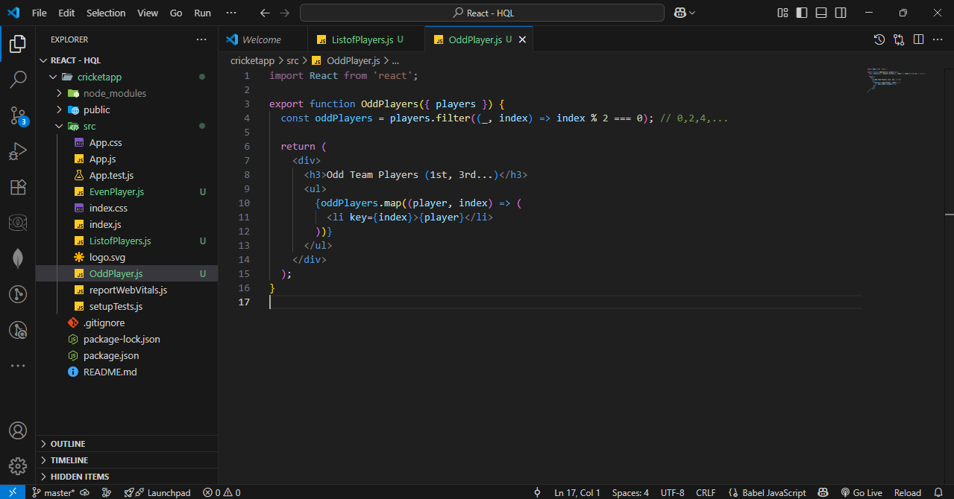

**EvenPlayer.js Code :**

import React from 'react';

export function EvenPlayers({ players }) {

const evenPlayers = players.filter((_, index) => index % 2 !== 0); // 1,3,5,...

return (

<div>

<h3>Even Team Players (2nd, 4th...)</h3>

<ul>

{evenPlayers.map((player, index) => (

<li key={index}>{player}</li>

))}

</ul>

</div>

);

}

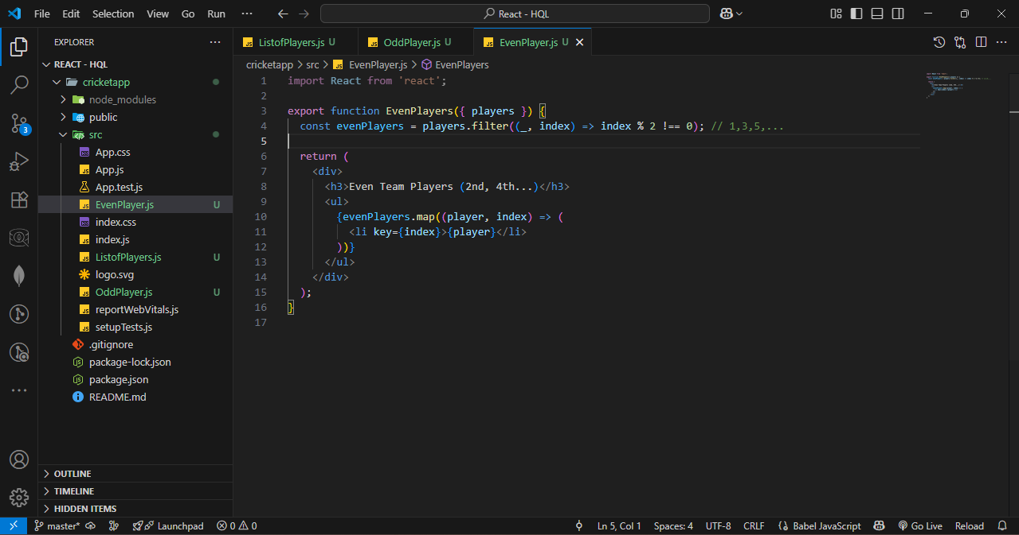

**Step – 4 :** Create a js file named IndianPlayer.js and Declare two arrays T20players and RanjiTrophy players and merge the two arrays and display them using the Merge feature of ES6.

**Code :**

import React from 'react';

import { OddPlayers } from './OddPlayers';

import { EvenPlayers } from './EvenPlayers';

const T20Players = ['First Player', 'Second Player', 'Third Player'];

const RanjiTrophyPlayers = ['Fourth Player', 'Fifth Player', 'Sixth Player', 'Seventh Player', 'Eighth Player', 'Ninth Player', 'Tenth Player', 'Eleventh Player'];

const allPlayers = [...T20Players, ...RanjiTrophyPlayers];

export const IndianPlayers = () => {

  return (

    <div>

      <h2>All Indian Players</h2>

      <ul>

        {allPlayers.map((player, index) => (

          <li key={index}>{player}</li>

        ))}

      </ul>

      <OddPlayers players={allPlayers} />

      <EvenPlayers players={allPlayers} />

    </div>

  );

};

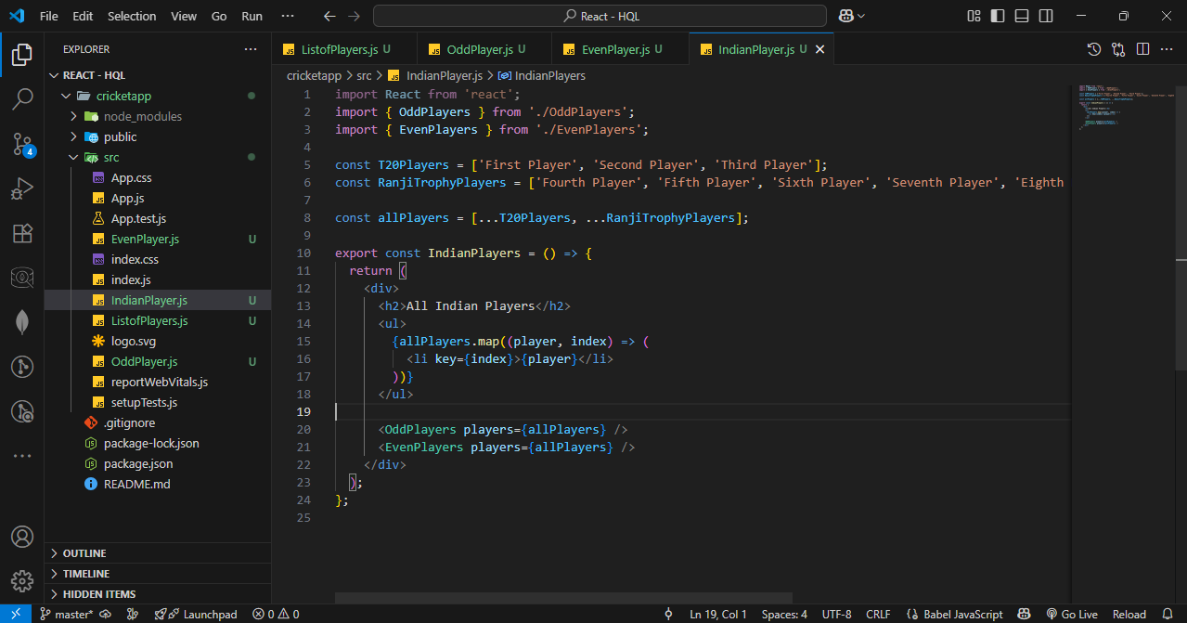

**Step – 5 :** Update App.js.

**Code :**

import React from 'react';

import ListofPlayers from './ListofPlayers';

import { IndianPlayers } from './IndianPlayers';

function App() {

  const flag = true;

  return (

    <div className="App">

      <h1>Cricket App</h1>

      {flag ? <ListofPlayers /> : <IndianPlayers />}

    </div>

  );

}

export default App;

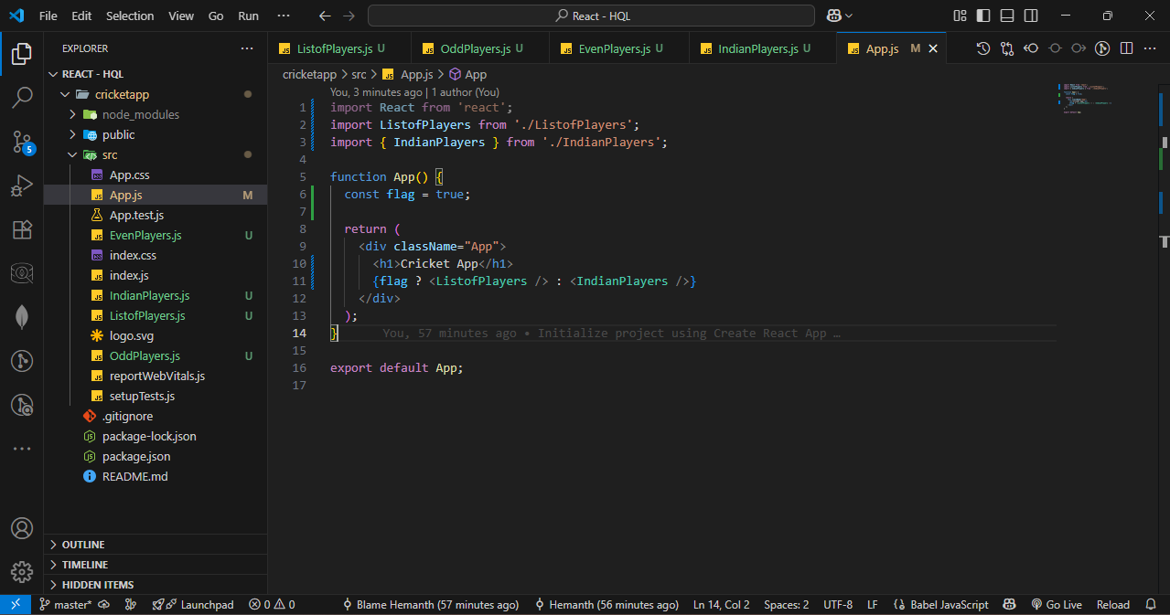

**Step – 6 :** Start the server.

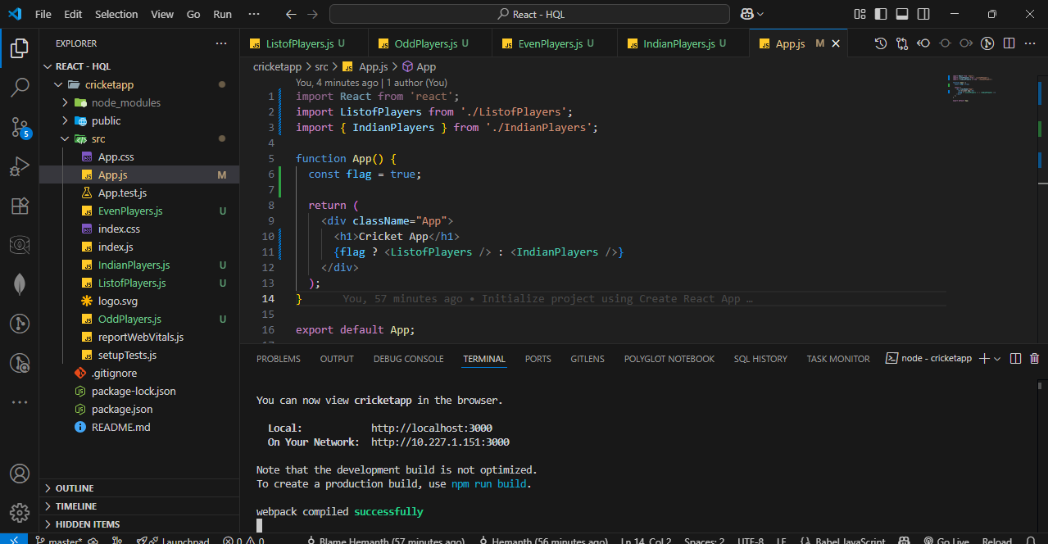

OUTPUT :

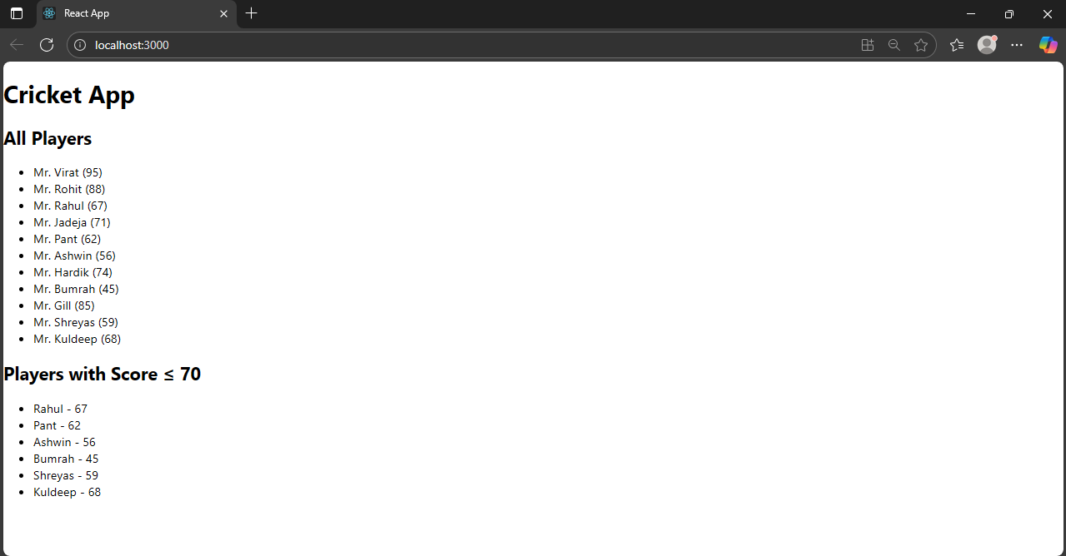

1. Office Space Rental App

**Step – 1 :** Create a react app named officespacerentalapp.

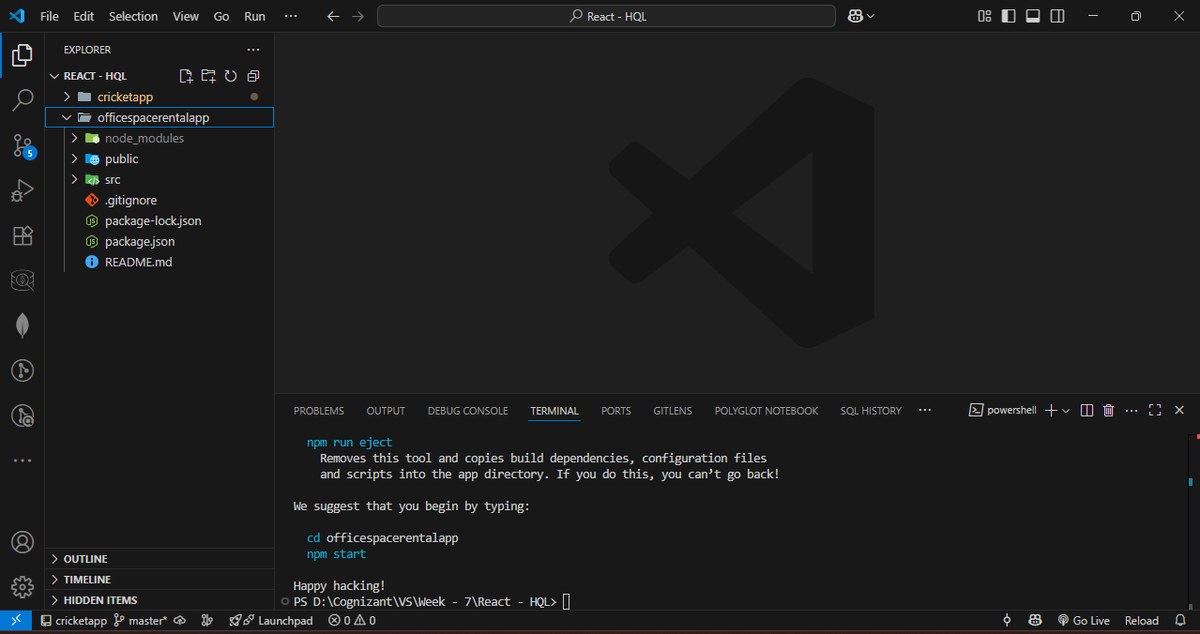

**Step – 2 :** update App.js and App.css

**App.js Code :**

import React from 'react';

import sr from './office.jpeg';

import './App.css';

function App() {

  const ItemName = { Name: "DBS", Rent: 50000, Address: "Chennai" };

  const rentColorClass = ItemName.Rent <= 60000 ? 'textRed' : 'textGreen';

  const element = "Office Space";

  const jsxatt = <img src={sr} width="25%" height="25%" alt="Office Space" />;

  return (

    <div

      style={{

        display: 'flex',

        flexDirection: 'column',

        alignItems: 'center',

        justifyContent: 'center',

        minHeight: '100vh',

        textAlign: 'center',

      }}

    >

      <h1>{element}, at Affordable Range</h1>

      {jsxatt}

      <h1>Name: {ItemName.Name}</h1>

      <h3 className={rentColorClass}>Rent: ₹{ItemName.Rent}</h3>

      <h3>Address: {ItemName.Address}</h3>

    </div>

  );

}

export default App;

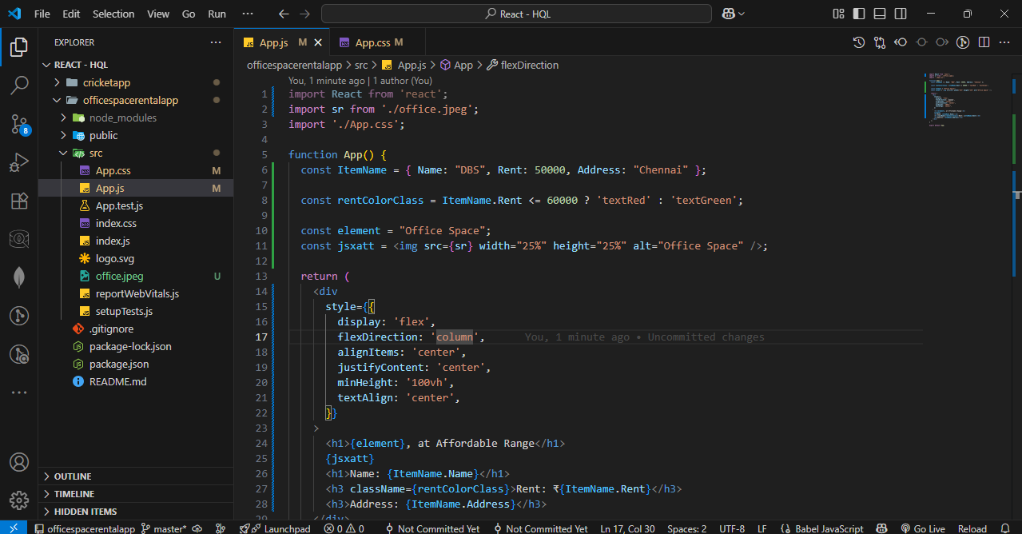

**App.css Code :**

.textRed {

  color: red;

}

.textGreen {

  color: green;

}

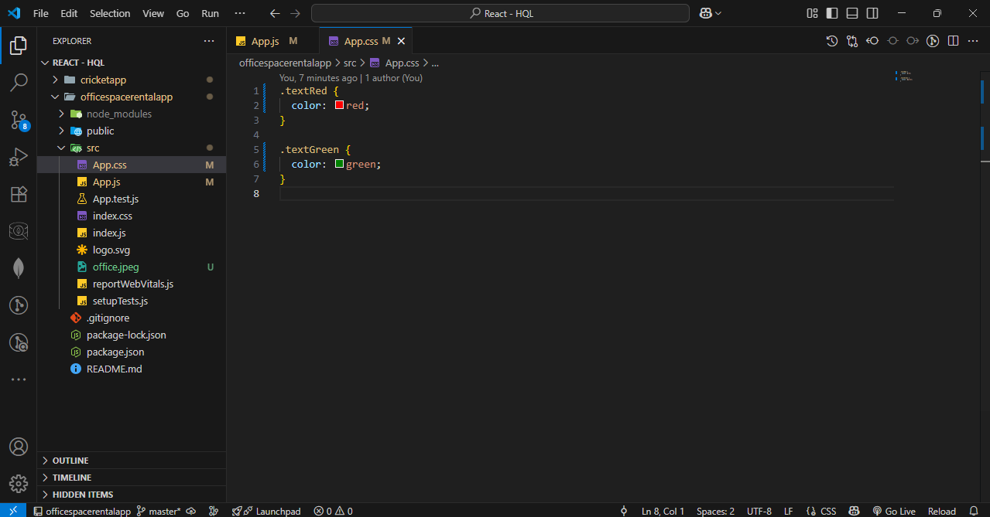

**Step – 3 :** Start the server.

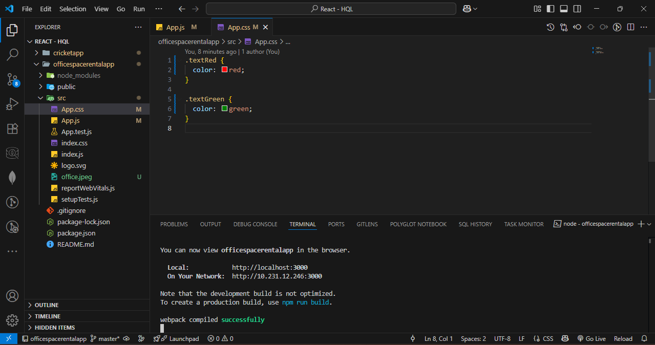

OUTPUT :

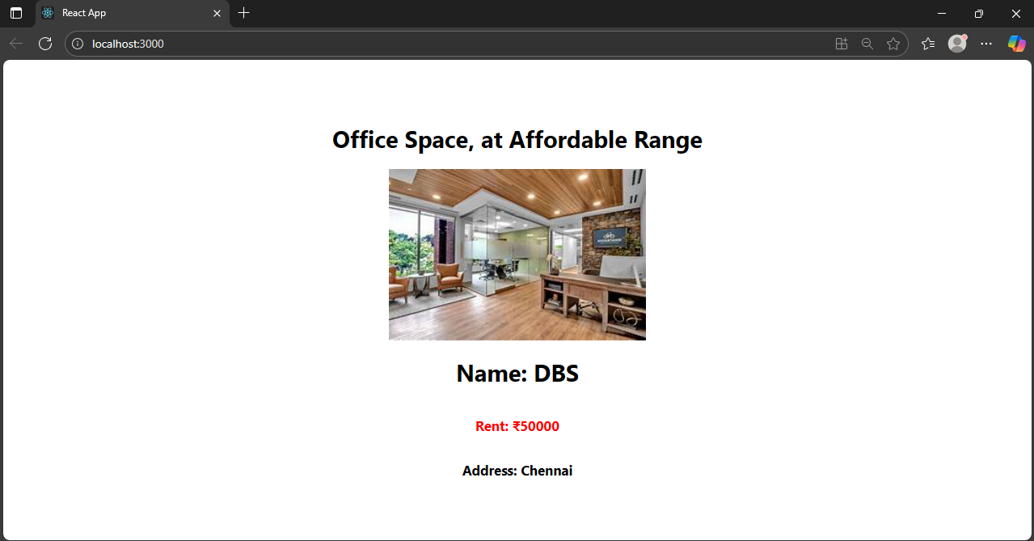

1. Event Example App

**Step – 1 :** Create a react app named eventexamplesapp.

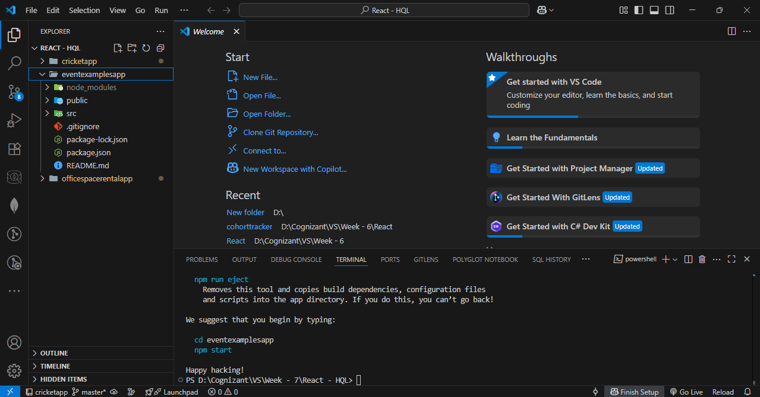

**Step – 2 :** Update app.js and app.css as per given instructions.

**App.js Code :**

import React, { useState } from 'react';

import './App.css';

function App() {

  const [count, setCount] = useState(5);

  const [amount, setAmount] = useState('');

  const [currency, setCurrency] = useState('');

  const sayWelcome = () => {

    alert("welcome");

  };

  const handleSubmit = (e) => {

    e.preventDefault();

    alert(`Converting ${amount} to ${currency}`);

  };

  return (

    <div className="app-container">

      <div className="counter">{count}</div>

      <div className="button-group">

        <button onClick={() => setCount(count + 1)}>Increment</button>

        <button onClick={() => setCount(count - 1)}>Decrement</button>

        <button onClick={sayWelcome}>Say welcome</button>

        <button onClick={() => alert('Clicked!')}>Click on me</button>

      </div>

      <h1 className="title">Currency Convertor!!!</h1>

      <form onSubmit={handleSubmit} className="currency-form">

        <div className="form-row">

          <label>Amount:</label>

          <input

            type="text"

            value={amount}

            onChange={(e) => setAmount(e.target.value)}

          />

        </div>

        <div className="form-row">

          <label>Currency:</label>

          <textarea

            value={currency}

            onChange={(e) => setCurrency(e.target.value)}

          />

        </div>

        <button type="submit">Submit</button>

      </form>

    </div>

  );

}

export default App;

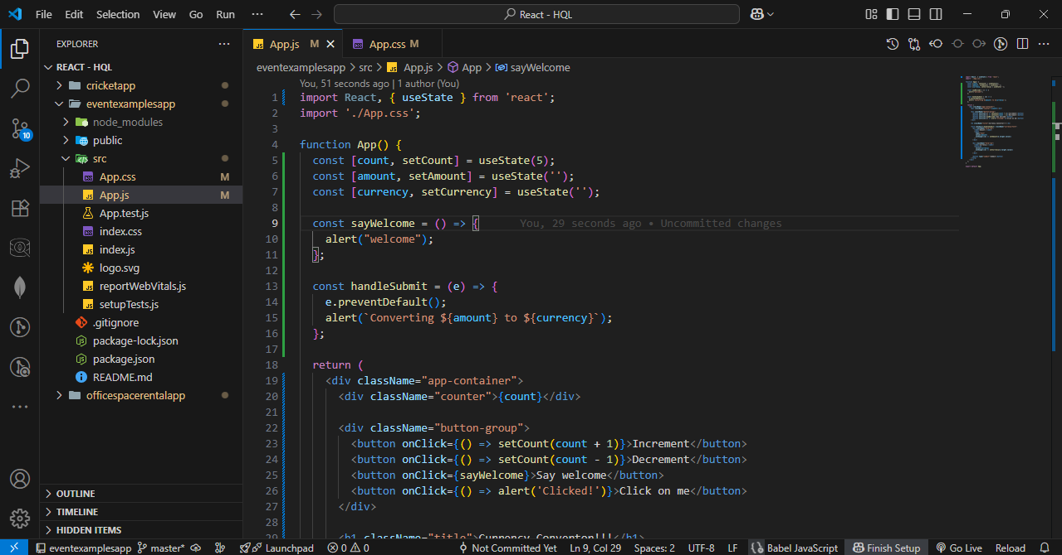

**App.css Code :**

.app-container {

  padding: 20px;

  font-family: Arial, sans-serif;

}

.counter {

  font-size: 20px;

  margin-bottom: 10px;

}

.button-group {

  display: flex;

  flex-direction: column;

  gap: 5px;

  max-width: 150px;

  margin-bottom: 30px;

}

.button-group button {

  padding: 5px;

}

.title {

  color: green;

  font-weight: bold;

  font-size: 28px;

  margin-bottom: 20px;

}

.currency-form {

  display: flex;

  flex-direction: column;

  gap: 15px;

  max-width: 300px;

}

.form-row {

  display: flex;

  align-items: center;

  gap: 10px;

}

label {

  width: 80px;

}

input, textarea {

  width: 150px;

}

button[type="submit"] {

  width: 100px;

  padding: 5px;

}

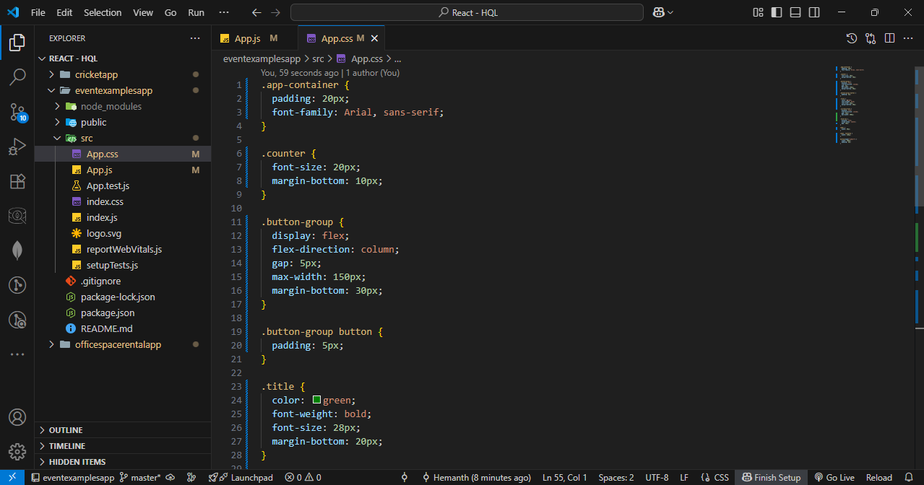

**Step – 3 :** Start the server.

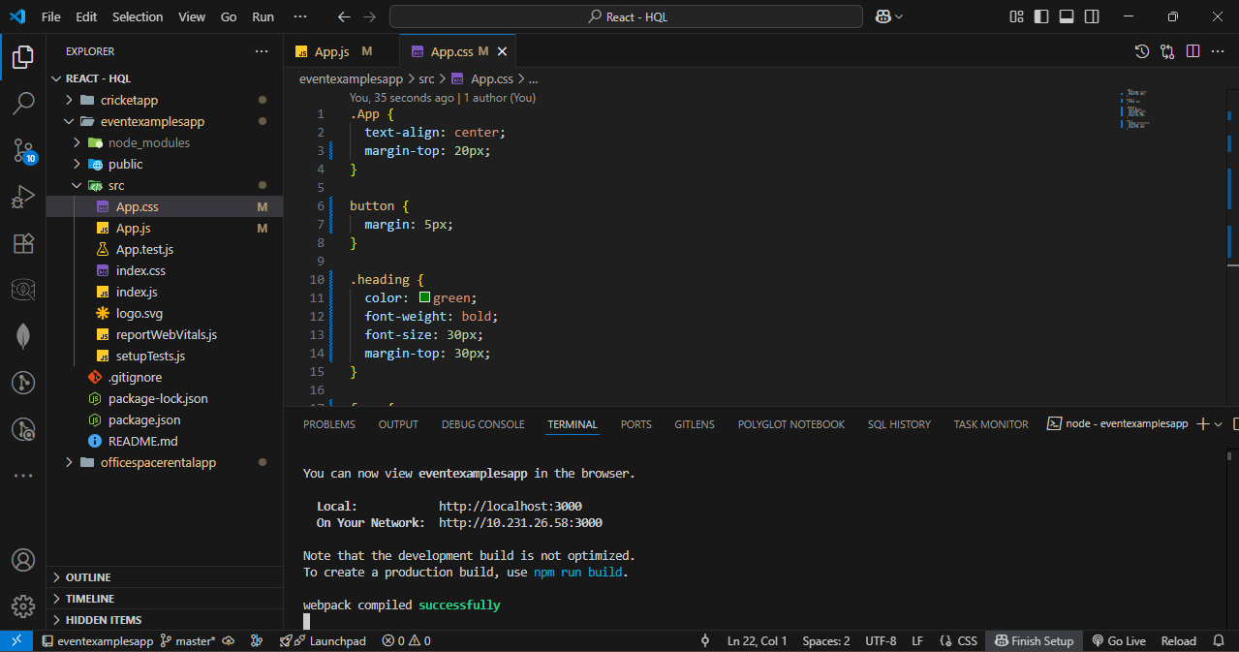

OUTPUT :

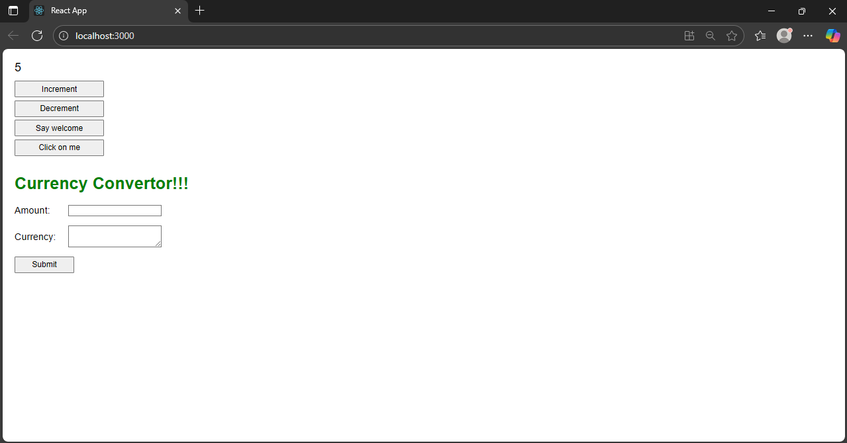

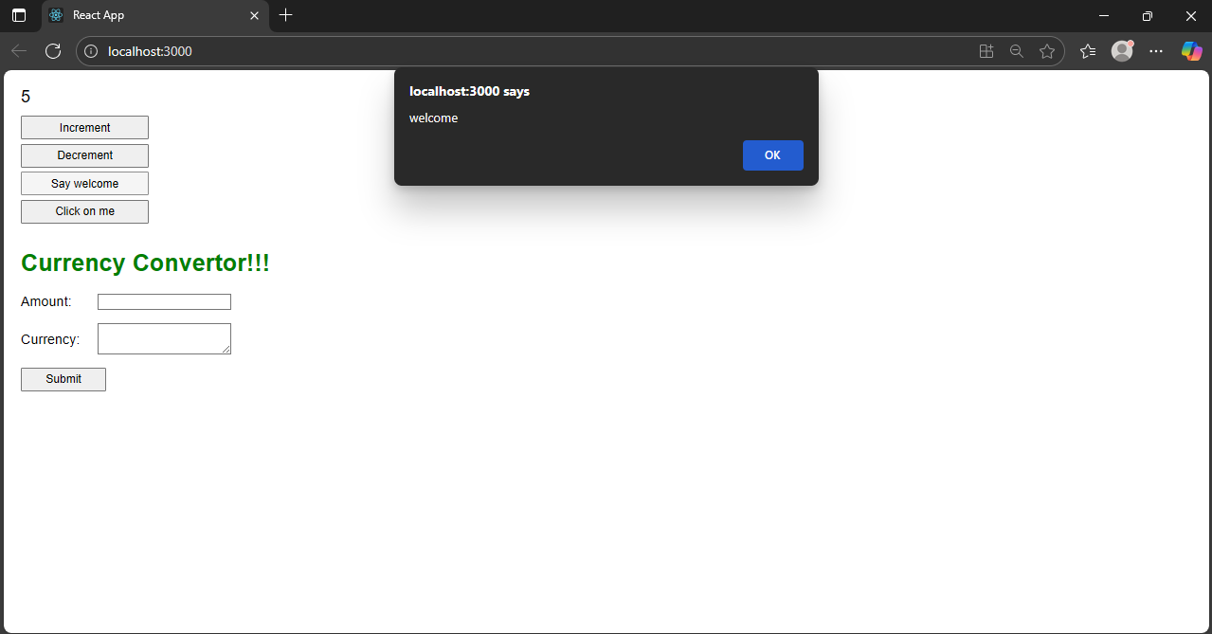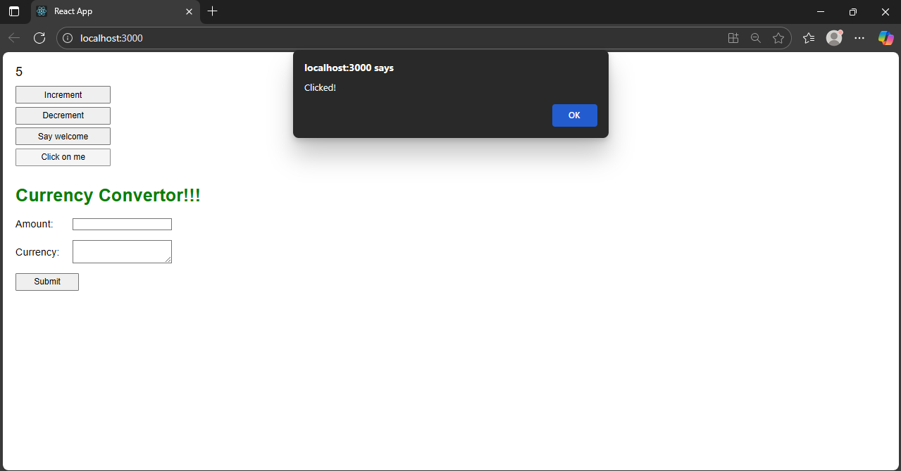

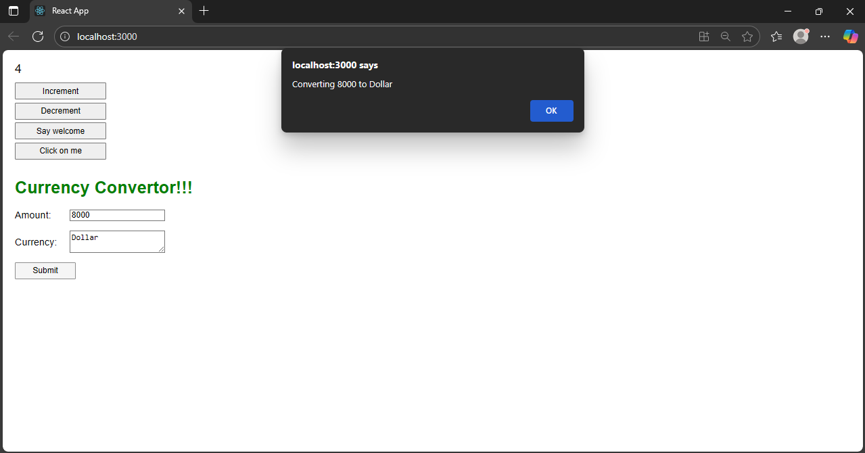

1. Login greating App.

**Step – 1 :** Create a react app named login-greating-app.

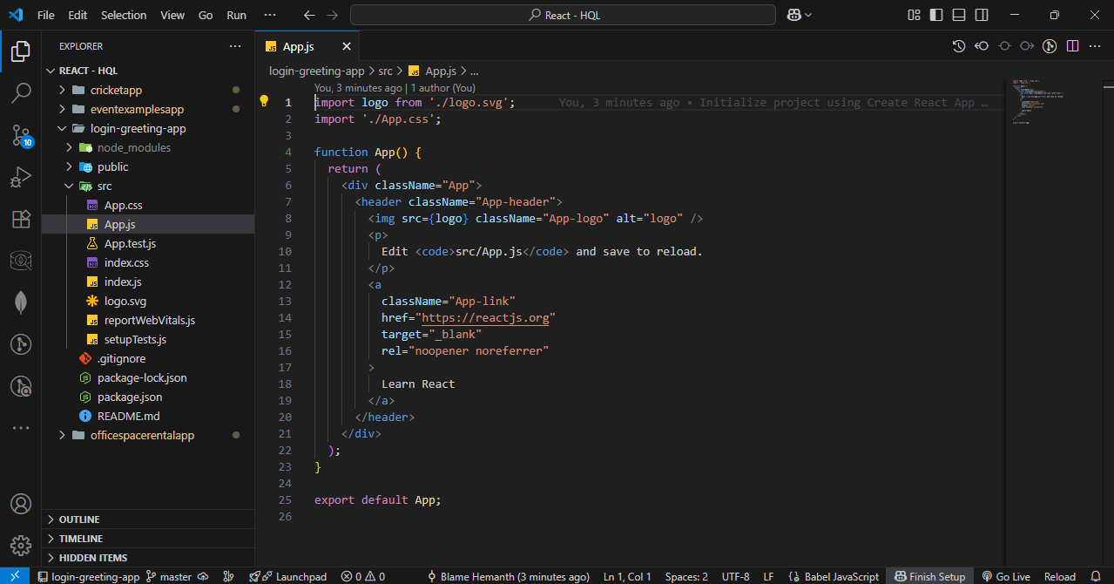

**Step – 2 :** Update the code of app.js and app.css as per instructions.

**App.js Code :**

import React, { useState } from 'react';

import './App.css';

function LoginButton({ onClick }) {

return <button className="btn" onClick={onClick}>Login</button>;

}

function LogoutButton({ onClick }) {

return <button className="btn" onClick={onClick}>Logout</button>;

}

function UserGreeting() {

return <h1 className="black-text">Welcome back</h1>;

}

function GuestGreeting() {

return <h1 className="black-text">Please sign up.</h1>;

}

function Greeting({ isLoggedIn }) {

return isLoggedIn ? <UserGreeting /> : <GuestGreeting />;

}

function App() {

const [isLoggedIn, setIsLoggedIn] = useState(false);

return (

<div className="container">

<Greeting isLoggedIn={isLoggedIn} />

{isLoggedIn ? (

<LogoutButton onClick={() => setIsLoggedIn(false)} />

) : (

<LoginButton onClick={() => setIsLoggedIn(true)} />

)}

</div>

);

}

export default App;

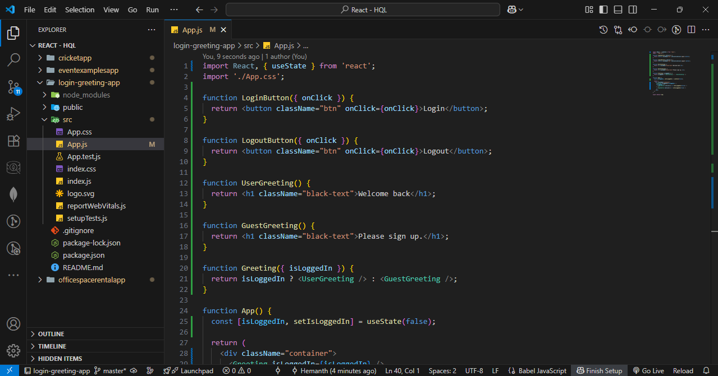

**App.css Code :**

.container {

text-align: center;

margin-top: 20%;

font-family: 'Arial', sans-serif;

}

.black-text {

color: black;

margin-bottom: 20px;

}

.btn {

padding: 10px 20px;

font-size: 16px;

cursor: pointer;

}

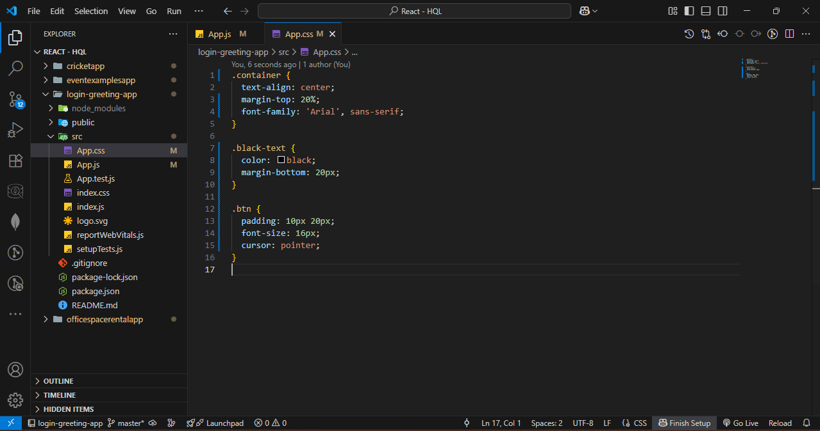

**Step – 3 :** Start the server.

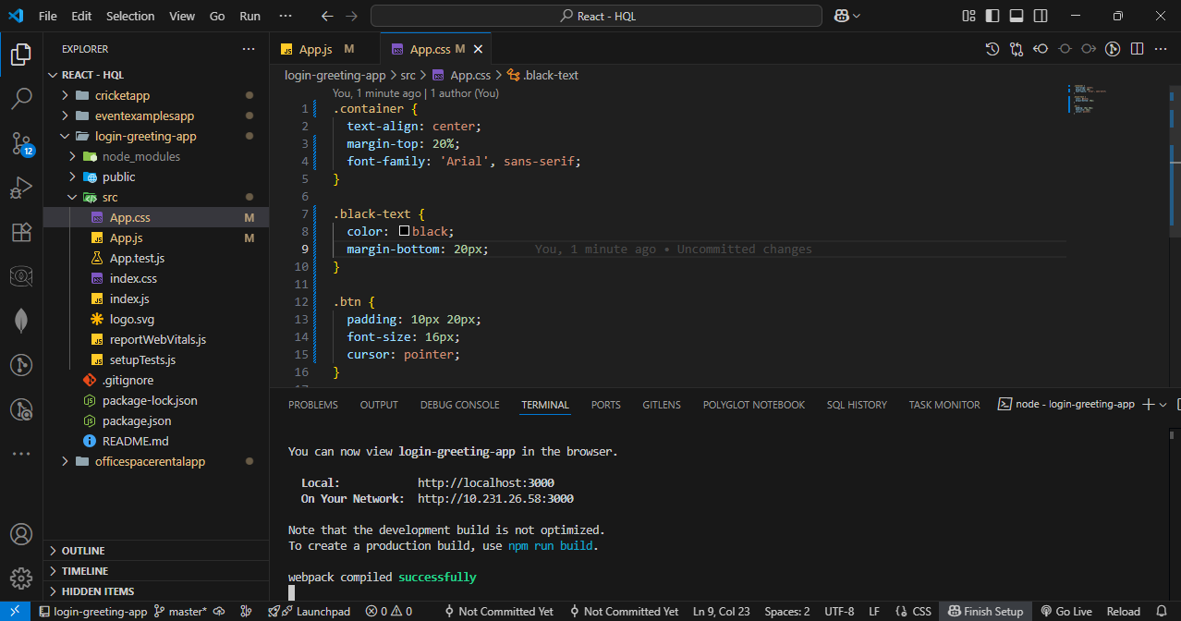

OUTPUT :

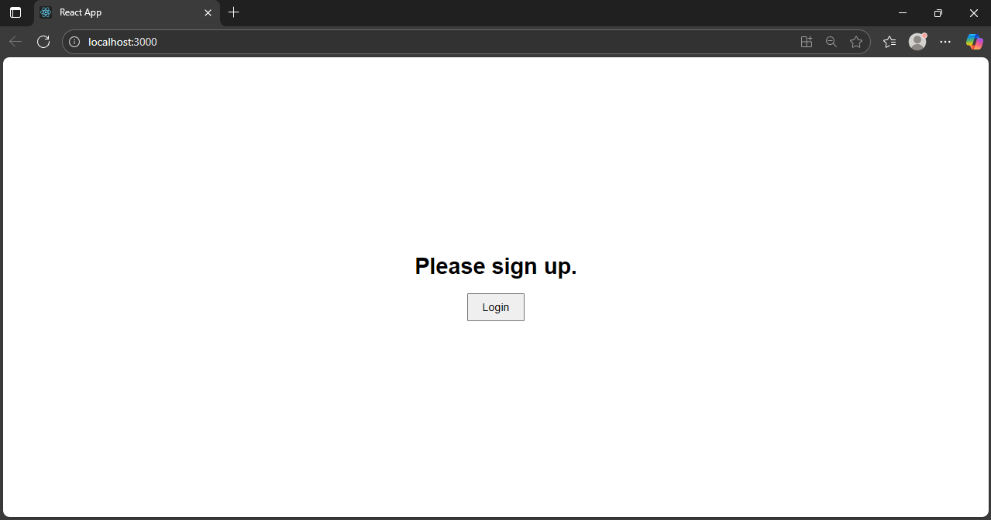

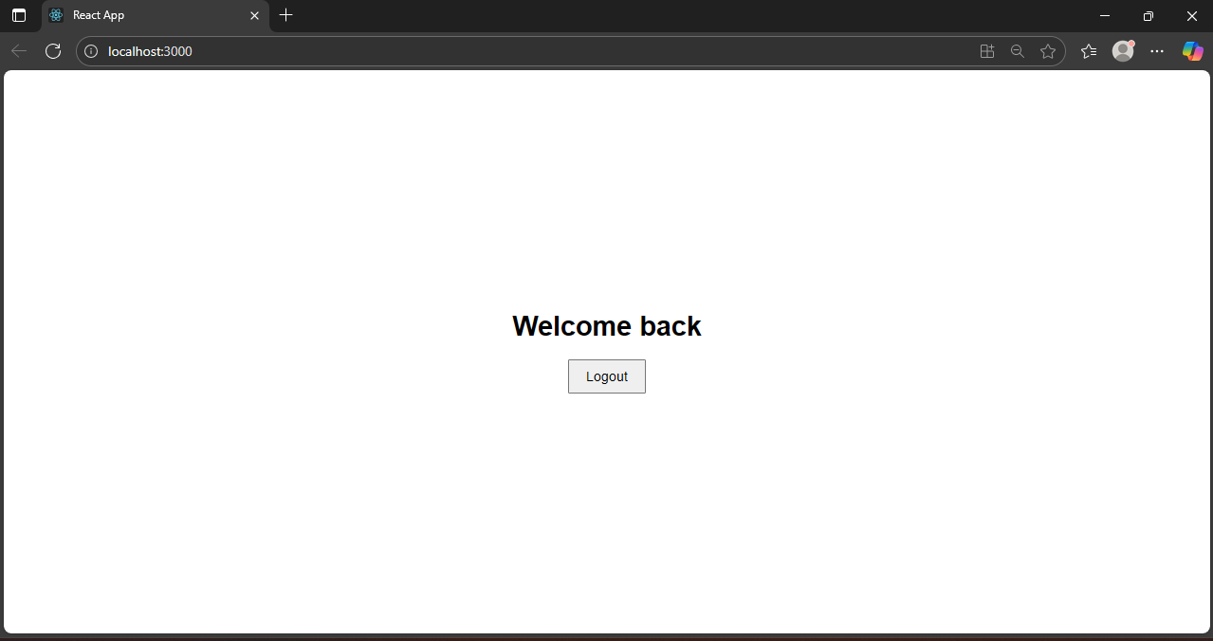

1. Blogger App

**Step – 1 :** Create a react app named bloggerapp.

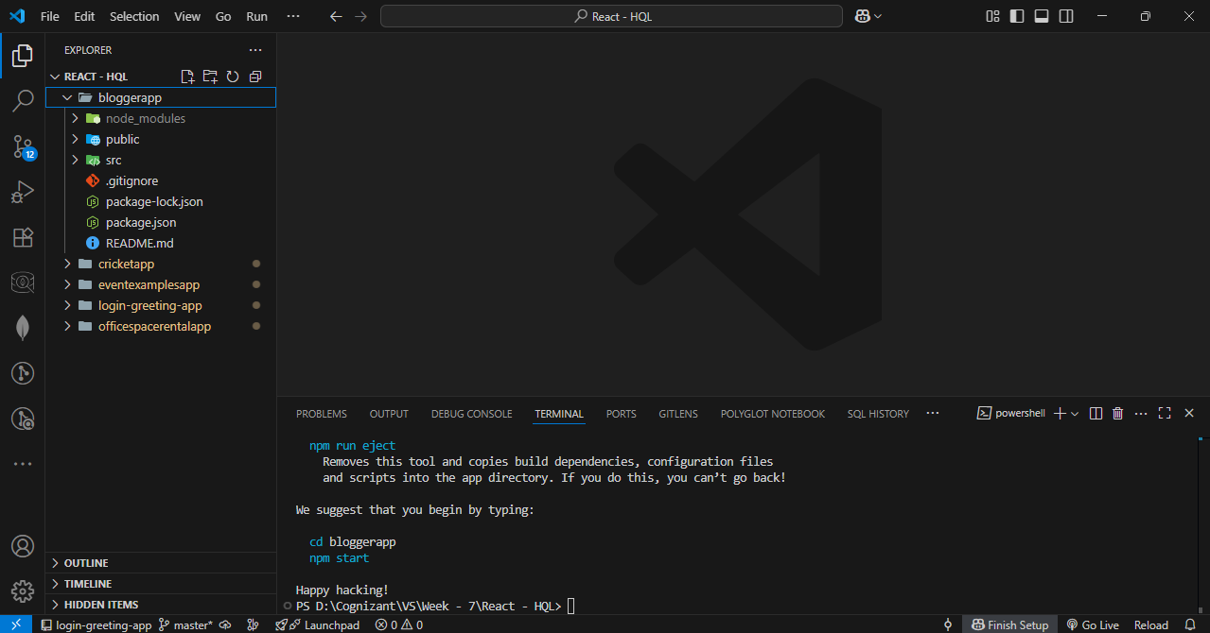

**Step – 2 :** Create two folders named components and data in src folder.

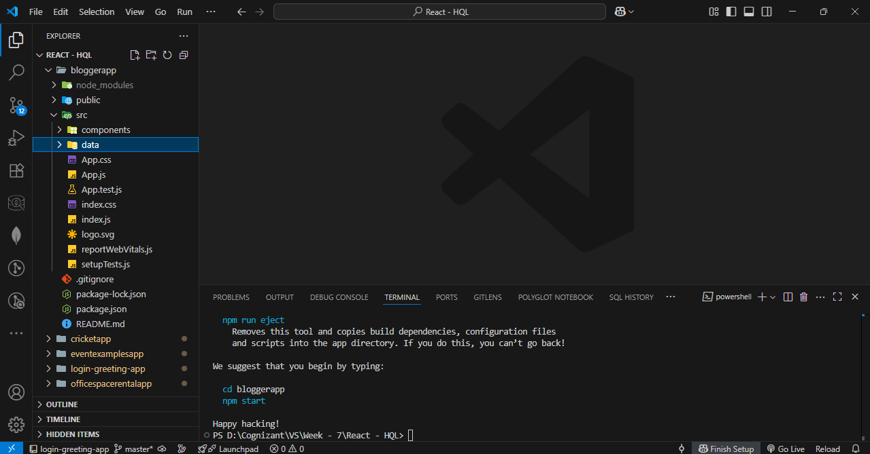  
  
**Step – 3 :** Create three files named BookDetails.js, BlogDetails.js, and CourseDetails.js in components folder.

**BookDetails.js Code :**

import React from 'react';

const BookDetails = ({ books }) => {

return (

<ul>

{books.map((book) => (

<div key={book.id}>

<h3>{book.bname}</h3>

<h4>{book.price}</h4>

</div>

))}

</ul>

);

};

export default BookDetails;

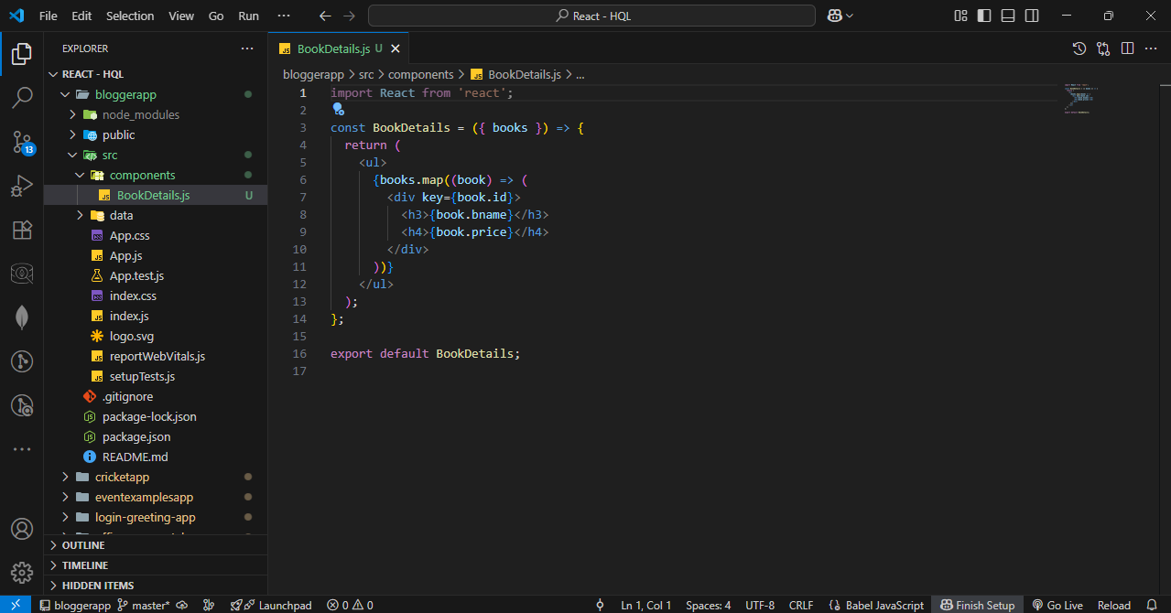

**BlogDetails.js Code :**

import React from 'react';

const BlogDetails = () => {

return (

<div>

<h2>React Learning</h2>

<h4>Stephen Biz</h4>

<p>Welcome to learning React!</p>

<h2>Installation</h2>

<h4>Schwezdenier</h4>

<p>You can install React from npm.</p>

</div>

);

};

export default BlogDetails;

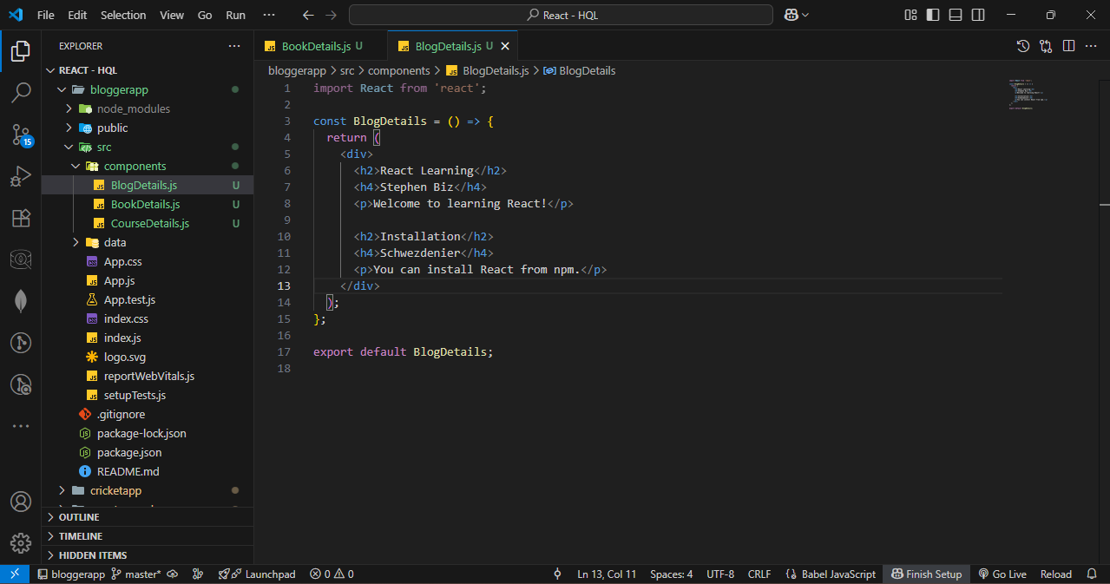

**CourseDetails.js Code :**

import React from 'react';

const CourseDetails = () => {

return (

<div>

<h2>Angular</h2>

<p>4/5/2021</p>

<h2>React</h2>

<p>6/3/20201</p> {/* Note: likely a typo in year */}

</div>

);

};

export default CourseDetails;

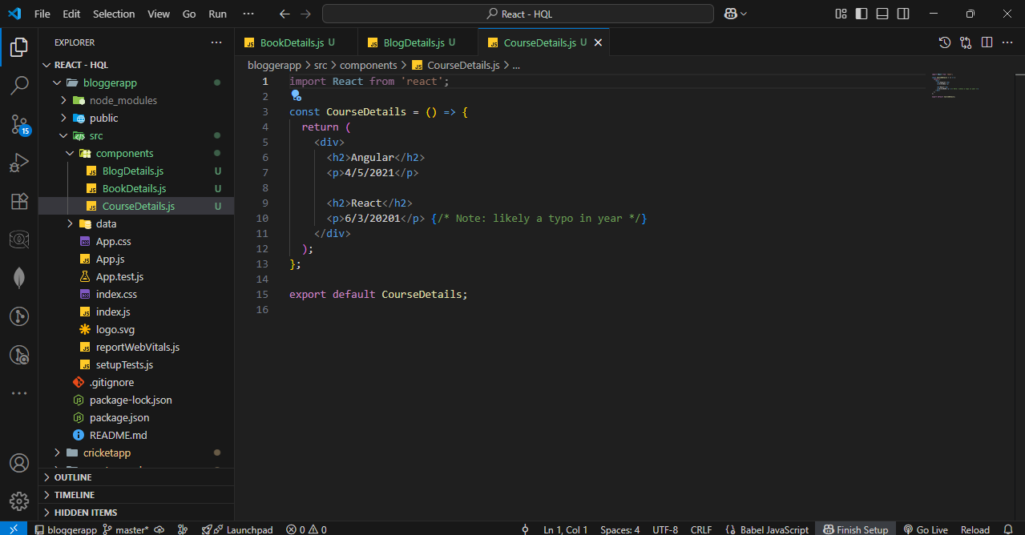

**Step – 4 :** Create three files named Books.js, Blogs.js, and Courses.js in data folder.

**Books.js Code :**

export const books = [

{ id: 101, bname: 'Master React', price: 670 },

{ id: 102, bname: 'Deep Dive into Angular 11', price: 800 },

{ id: 103, bname: 'Mongo Essentials', price: 450 },

];

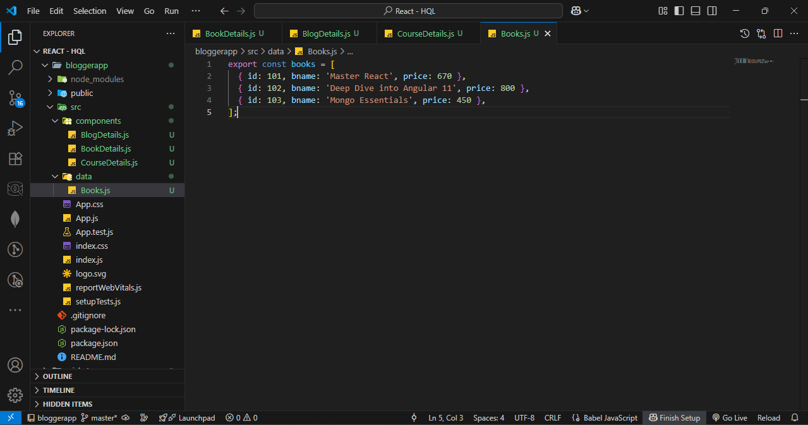

**Blogs.js Code :**

export const blogs = [

{

id: 201,

title: 'React Learning',

author: 'Stephen Biz',

description: 'Welcome to learning React!',

},

{

id: 202,

title: 'Installation',

author: 'Schwezdenier',

description: 'You can install React from npm.',

},

];

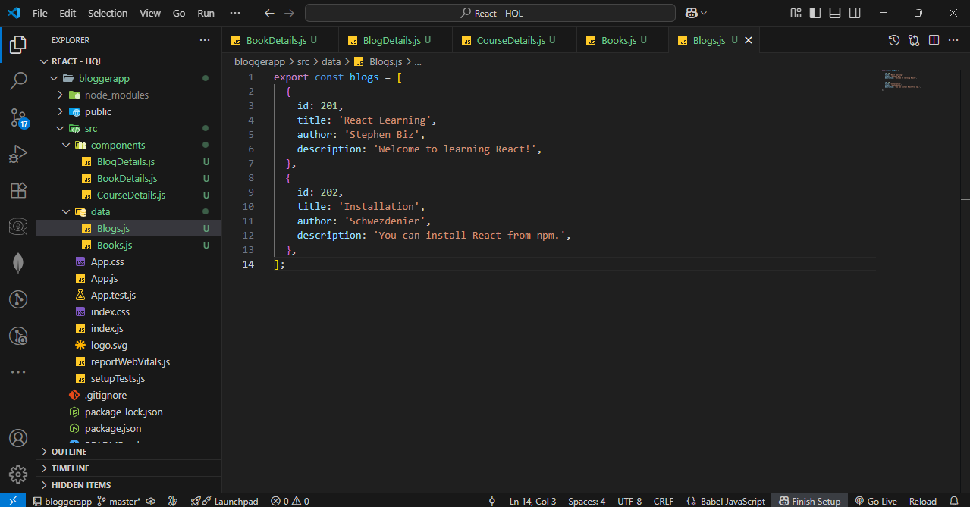

**Courses.js Code :**

// src/data/courses.js

export const courses = [

{

id: 301,

name: 'Angular',

date: '4/5/2021',

},

{

id: 302,

name: 'React',

date: '6/3/2021',

},

];

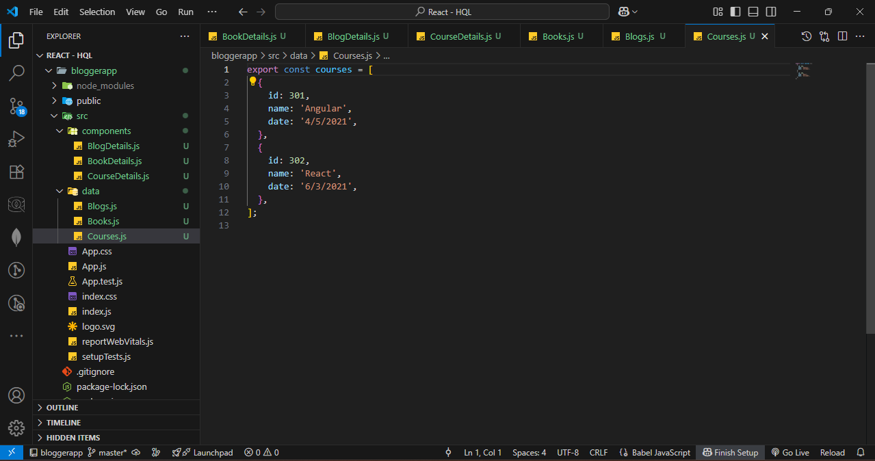

**Step – 5 :** Update app.js.

**App.js Code :**

import React, { useState } from 'react';

import './App.css';

// Import data

import { books } from './data/Books';

import { blogs } from './data/Blogs';

import { courses } from './data/Courses';

// Import components

import BookDetails from './components/BookDetails';

import BlogDetails from './components/BlogDetails';

import CourseDetails from './components/CourseDetails';

function App() {

  const [showBooks, setShowBooks] = useState(true);

  const [showBlogs, setShowBlogs] = useState(true);

  const [showCourses, setShowCourses] = useState(true);

  return (

    <div className="container" style={{ display: 'flex', justifyContent: 'space-around', padding: '20px' }}>

      {/* Course Details */}

      {showCourses && (

        <div className="mystyle1" style={{ borderLeft: '5px solid green', paddingLeft: '20px' }}>

          <h1>Course Details</h1>

          <CourseDetails courses={courses} />

        </div>

      )}

      {/* Book Details */}

      {showBooks && (

        <div className="st2" style={{ borderLeft: '5px solid green', paddingLeft: '20px' }}>

          <h1>Book Details</h1>

          <BookDetails books={books} />

        </div>

      )}

      {/* Blog Details */}

      {showBlogs ? (

        <div className="v1" style={{ borderLeft: '5px solid green', paddingLeft: '20px' }}>

          <h1>Blog Details</h1>

          <BlogDetails blogs={blogs} />

        </div>

      ) : (

        <p>No blogs to show</p>

      )}

    </div>

  );

}

export default App;

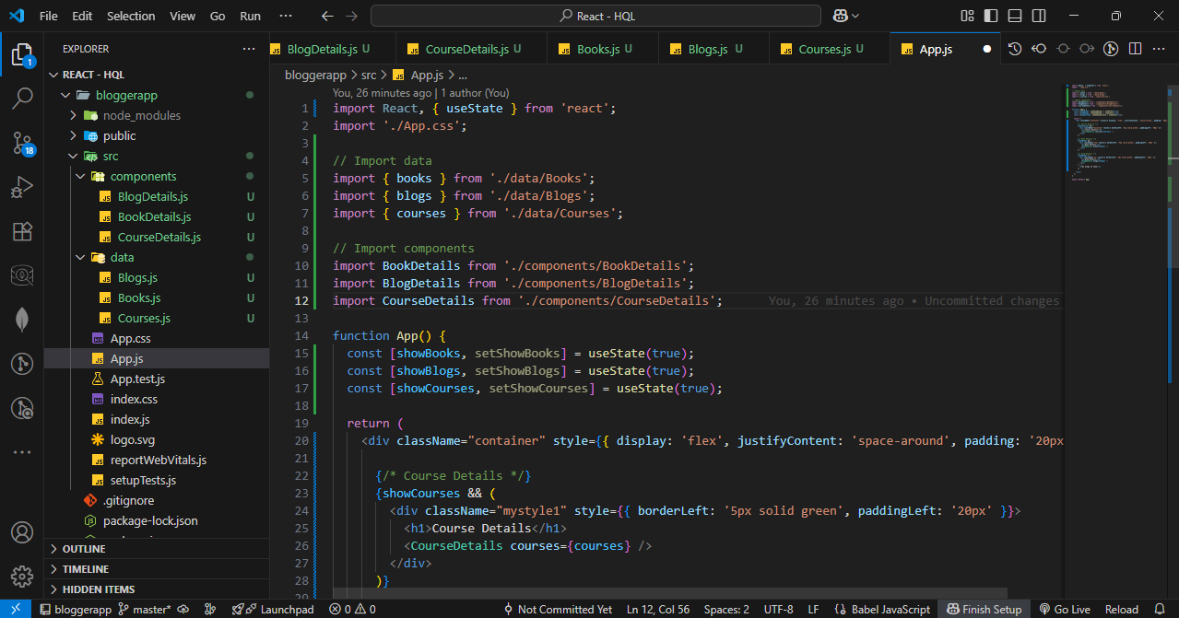

**Step – 6 :** Style it with app.css.

**App.css Code :**

.container {

  display: flex;

  justify-content: center;

  align-items: center;

  gap: 60px;

  height: 100vh;

  padding: 20px;

  box-sizing: border-box;

}

.section {

  border-left: 5px solid green;

  padding-left: 20px;

  min-width: 220px;

}

.section0 {

  min-width: 220px;

  font-size: x-large;

}

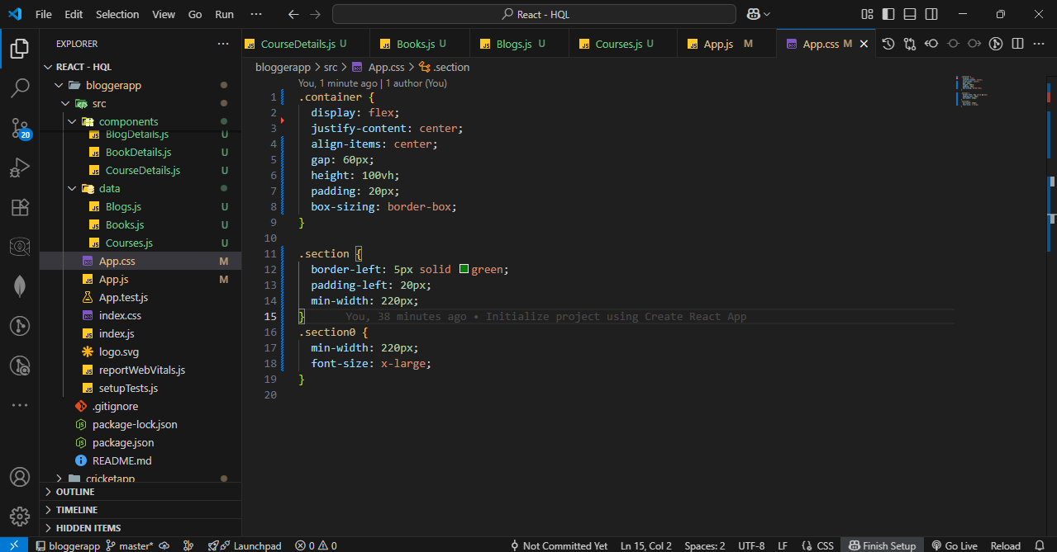

**Step – 5 :** Start the server.

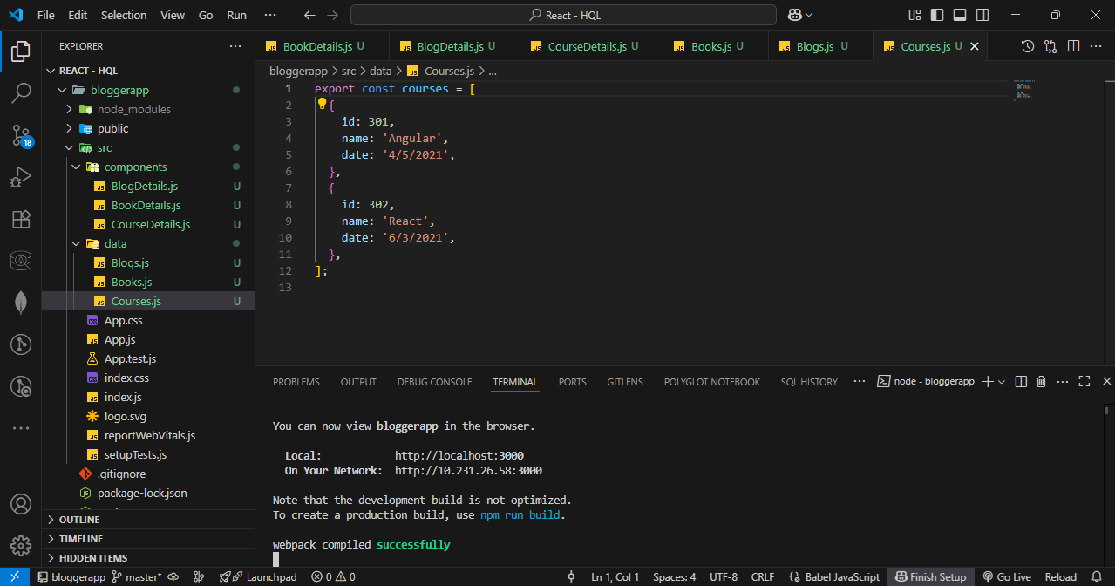

OUTPUT :

